

By the end of this session, you will be able to:

- Identify what wayfinding projects are and how they can become lucrative for a center.

- Understand the components of an effective wayfinding solution.

- Readily identify pictograms and understand why they are a necessary component of a wayfinding solution.

- Interpret a wayfinding system and the decision points.

- Understand the process to go through (questions to ask, resources to search for) to determine whether or not to accept this type of a project.

- Learn how to deliver wayfinding proposals with product quotes within 100 hours* of the completed site survey.

WAYFINDING:
- The process of directing a user along a path or course to a desired destination.

An effective wayfinding system will provide both the frequent and infrequent user the easiest and most direct route towards their target destination.

An ineffective system can confuse and frustrate users and can cause pedestrian traffic problems.

Brain Teaser: Think about a place you recently visited. This is a place of business or a place of commerce or a transportation area—a place bustling with activity. This place could be a shopping mall…Or a large hospital. Perhaps it is an office building in the downtown area or a school campus. You are on a busy street trying to find and enter this place. What will you look for in order to get to your final destination?

SITE

PARKING/VALET
BUILDING ENTRY

FINAL DESTINATION

Site:
Parking/Valet:
Building Entry:
Final Destination:

Planning an Effective Wayfinding System

Follow these Basics:

- Create an identity at each location, different from all others.
- Use landmarks to provide orientation cues and memorable locations.
- Create well structured paths.
- Create regions with different visual characteristics.
- Do not give the navigator too many choices.
- Provide navigators with a map or visual aide.
- Provide signs at decision points. How do you know if a sign is needed and the location is a decision point? Ask yourself these questions:

- ______________________________________________________________________________
______________________________________________________________________________

- ______________________________________________________________________________
______________________________________________________________________________

The Universal Sign Language

- Every wayfinding signage system will include specifications of the Universal Language through the use of pictograms.

- A pictogram (or a Symbol) speaks ALL languages.

Typical Wayfinding Signage

Highway Signs

- Pictograms

Site Identification Signs

- Monument signs

Parking Area Signs

- Parking garage identification
- Handicap parking areas

Exterior Building Signage

- Various entrance signs

Interior Building Signage

- Directionals
- Room identification signs

Case Study: DFW International Airport

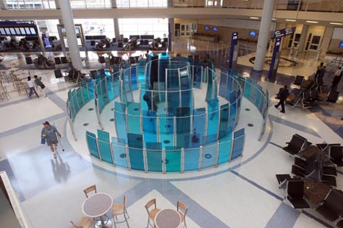

A little History

The Americans with Disabilities Act (ADA) went into effect on January 26, 1992 changing the landscape of how ADA signage is marketed and sold.
For Canadian centers, there is no ADA equivalent at this time. The “Canadians with Disabilities Act” has been proposed several times and several parties (including the Conservative Party and the Green Party) favor it; however, it has yet to pass. It is estimated that Canadians with disabilities represent approximately 15% of the population.

- Wayfinding systems, in order to be effective, must be as usable as possible for everyone whether in a wheelchair, hearing impaired or vision impaired.
- As the degree of disability varies, it is important to consider a variety of systems to accommodate as many people as reasonably possible.
- A wayfinding system should be designed for clear and efficient ________________.
The Wayfinding Project Bidding Process

- You are the best judge of your center’s capabilities, talents and resources. You know best what jobs you can complete, what vendors you can rely on and what vendors you CANNOT rely on.

- Request for Proposal (RFP) is a publication of the detailed requirements needed and specified by a customer in order to receive vendor pricing.

- RFP is also known as: request for proposals, request for bid, and request to quote or invitation to bid.

- Most RFPs specify the content of the proposal and dictate a specific format that must be followed when submitting the proposal. Others simply describe the final product needed, leaving the content and formatting up to you.

There are 4 Types of Bid Processes you might encounter:
A Hard Bid Contractor provides the budget amount.
A Negotiated Bid Vendor and Contractor meet discuss details and agree on a dollar amount.
A Competitive Bid More than one vendor will submit a bid – there is a chance for negotiation.
A Closed Bid More than one vendor will submit a bid – there is no chance for negotiation.

The Wayfinding Bidding Process…
Examples of Questions to ask the CUSTOMER:

- Who else is bidding the project?
- What is the time frame to complete the Site Survey, Estimate process, Actual project?
- Will a set of blueprints be provided?
- If there is not a blueprint, can you have access to the site map?
- Can a member of the site staff be made available to assist with the site survey?
- Who is the decision maker?
- If there are multiple bids, will be a meeting established for each vendor to come meet with the contractor, discuss details and negotiate products and/or dollars.
- How will the vendor be contacted with approval?
- What are the insurance requirements for Sub-Contractors?
- Are there any special sign or permit requirements known? Who pulls them?
- Will this project include a standard contract? A purchase order?
- What are the payment terms?

The Wayfinding Bidding Process…
Examples of Questions to ask YOURSELF:

- What is the reputation of the customer, general contractor, and/or architect?
- Who else is bidding the project? Are they a direct competitor?
- Is the project time frame to complete the project within the capability realms of your center?
- What are the requirements of the staff—design elements, staffing, etc?
- Can you service your existing customers adequately while facilitating this project?
- How much of the project will be in-house vs. sub-contract?
- Do you have local sub-contractors you can rely on and trust to produce specialty signage?
- Do you have local installers you can rely on? Are they insured?
- Will your in-house equipment support the productions needs?
- How much of a deposit is required to cover set up costs? Is that amount feasible – will the customer agree to pay that up front?
- Will the payment terms allow you to manage cash flow efficiently?

The Site Survey

What to bring with you:
The site area blueprint or site map, large pad of template paper, pencils, rulers, a level and a digital camera.

- A well-drawn template, with effective notes and photos, will be your best friend upon arriving back to your center.
- Materials are cut, money is spent and costs incurred based entirely on the information you bring back from a site survey.
- Make the templates count!

- Understand what areas are permanent/temporary.
- Note the length and depth of all of the new signs(s) needed.

- Note location of any obstructions-Trees, gates, awnings, etc.
- Note any intricate cornice etc. that will effect the sign
- Note the depth of any recessed areas(s)
- Note any other possible problem areas
- Note any air conditioning and/or ventilation grills
- What signs need electricity? Where is the supply?

At any point during the site survey, if you are in doubt,
MEASURE and PHOTOGRAPH the area AGAIN.

Site Survey Class Activity
What Sign Belongs in the Photo?

Photo
1
2
3
4
5

Recommending Wayfinding Sign Packages for Developers
- Sign package bid should be on company letterhead or a specially designed bid template.
- The more information you include in your bid, the least chance there is for question or misinterpretation by your client.
- Break down sizes, quantities and specific materials to be used
- Provide final cost for each sign (x the quantity) as well as the total overall bid amount.
- Make sure that the wording within the quote (contracts) allows for additional trips to the site.
- Specify the terms of any change orders (any change to the contract which might include additions, dedications, modification to the work or time, etc.).
- Include payment terms as agreed upon by the client.

Estimate your cost accurately by:
  - Determining the actual cost and the markup you will need to include in order to profit
  - Estimating the labor in in-shop production
  - Determining the installation time and number of trips that will need to be made to site

Resource Section
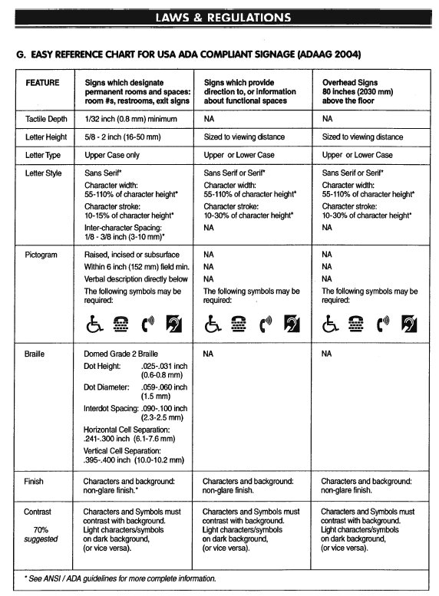
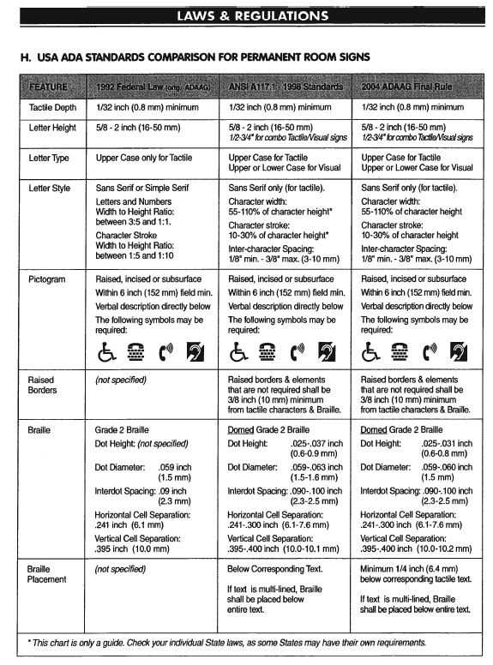
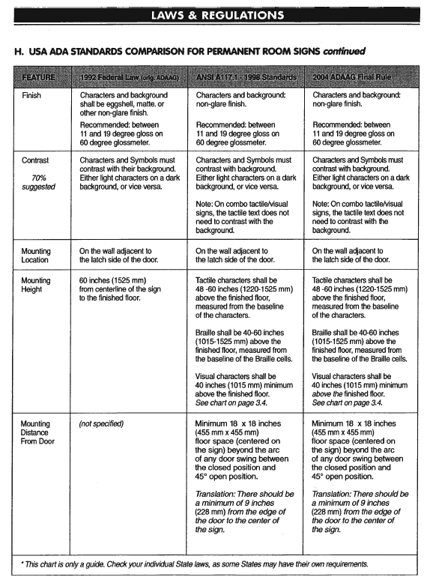
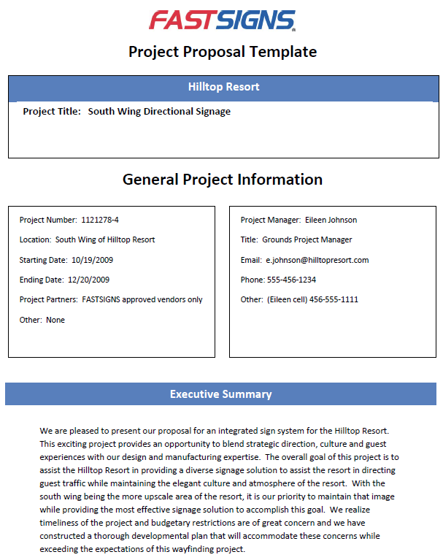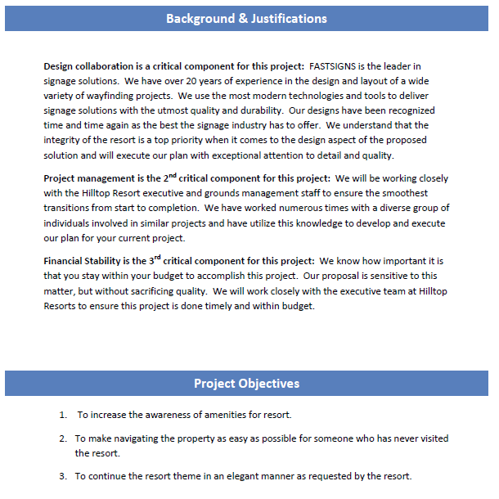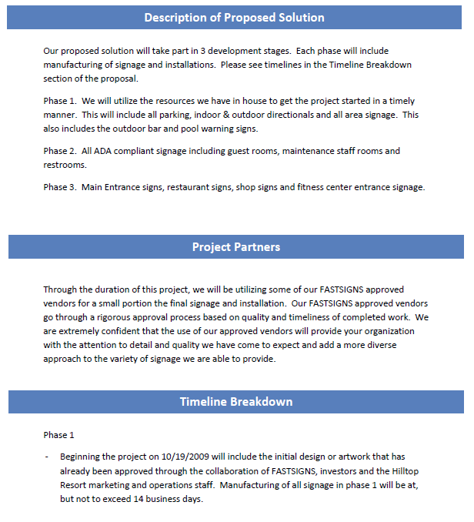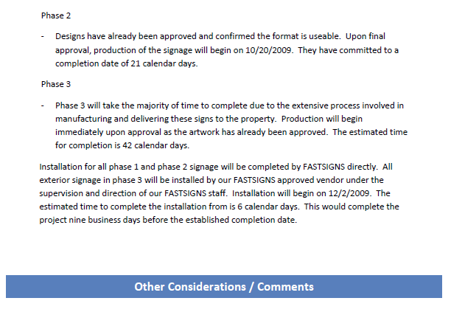

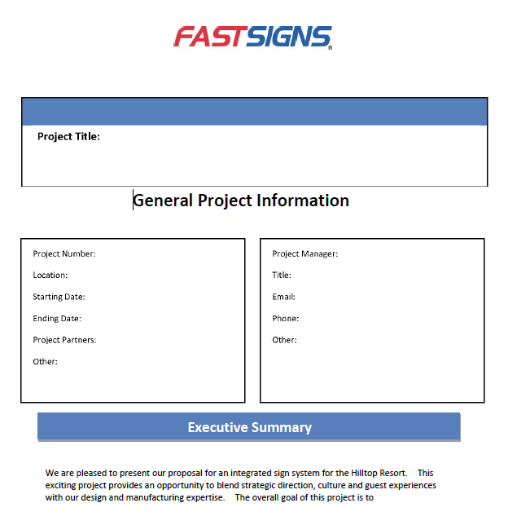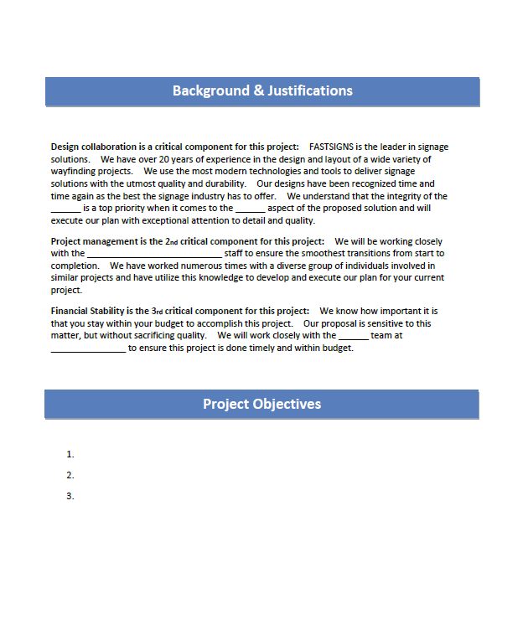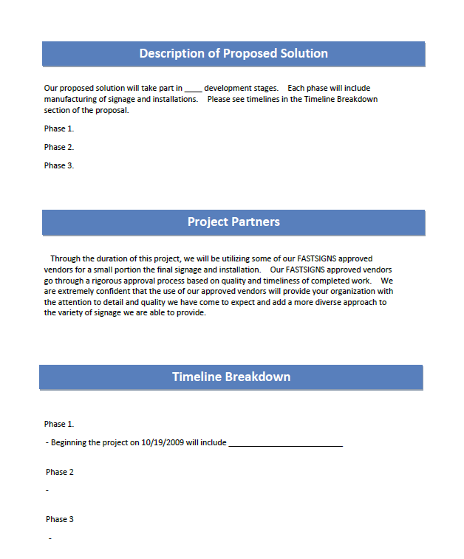

Successful Wayfinding Questions
The following checklist of questions will help to ensure you have a successful project.
- What is the reputation of the customer, general contractor, and/or architect?
  - Will they provide you with references from other vendors?
- Competition:
  - Who else is bidding the project?
- Will a set of blueprints be provided?
  - At what cost?
  - Location to pick them up?
- If no blueprints are available –
  - Interview all responsible parties to determine the expectations of the project.
  - Are the vendors responsible for completing the site survey?
  - Can the contractor supply a floor plan or site map?
  - Will a member of the site staff be available to assist with the site survey?
  - Can one site be surveyed and all other sites will follow suit or does each location need to be reviewed?
    - How many sites are there and the location of each?
  - Will one vendor complete the survey and all others will follow suit?
  - Is there a separate line item in the budget to pay for the survey?
  - If each vendor is responsible for their own site survey –
    - How will the contractor establish consistency for reviewing purposes?
  - If each vendor will submit their own version of the scope of work –
    - Will there be a meeting established for each vendor to come meet with the Contractor, discuss details and negotiate products and/or dollars?
- What is the time frame to complete the following –
  - Site Survey
  - Estimate process
  - Actual project
  - Are you willing to take on a project that could last as long as a year?
  - Is the timeline to complete so close that it will require overtime from your staff as well as the sub-contractors staff?
- Who is the decision maker?
  - The General Contractor
  - The General Contractors customer
  - The Architect
  - A Committee
- What is the time frame for the final decision?
  - How will the vendor be contacted with approval?
- What are the insurance requirements for Sub-Contractors i.e. Installers
- Are there any special sign or permit requirements
  - Landlord specifications
  - City Permit office
  - County or State government
- If permits are required – who will pull them?
  - The General Contractor
  - The Customer
  - The Sign Vendor
- Will this project include a standard contract?
  - Will the contract be provided by the Contractor?
  - Ask to review the contract before completing the estimate
  - What are the expectations of the vendor?
- If the project will be paid with a purchase order agreement –
  - What are the terms of the agreement?
- What are the payment terms –
  - Will the Customer pay a 50% deposit at time of signing the contract?
  - Will the Customer agree to an installment payment program?
  - Is a there a retainer fee attached to this project?
    - If so – at what percent?
      - Typical amount = 10%
    - What is the time to finalize the payment?
  - How will change orders be addressed and approved?
- Requirements of the staff
  - If the project requires specific design elements does your designer have the skill set to complete the project?
  - Do you have the administrative help to facilitate the project?
- Will you need to hire additional staff for this project?
  - Will they be full time or part time?
  - Temporary or permanent?
- Can you service your existing customers adequately while facilitating this project?
- Will your sales growth suffer during the months this project is being completed?
- How much of the project will be produce in-house vs. sub-contract?
- Do you have local sub-contractors you can rely on and trust to produce specialty signage?
  - Are the subs in your territory or out of state?
  - Will the subs travel to your location to assist with site inspections?
- Do you have suppliers that you can rely on to ship supplies on time
  - Will they give you pricing discounts for volume purchasing?
  - Are you required to purchase the entire inventory at once or can you purchase in phases and still receive bulk pricing?
- Do you have local installers you can rely on?
  - Do they have the appropriate insurance?
  - Will they obtain the insurance necessary for this project?
- Will your in-house equipment support the productions needs?
  - In using the in-house equipment – will it slow down day to day production?
  - What is your back up plan if the in-house equipment goes down?
- Do you need to purchase a new piece of equipment to meet the production needs?
  - What is the cost of the equipment?
    - Can you allocate a portion of the purchase price into the bid?
  - Can you prorate a portion of the equipment cost into the bid?
  - How long will it take to receive delivery?
  - What is the learning curve for the staff on this equipment?
  - Do you have a local vendor to support any challenges on the equipment?
- How will this project effect cash flow?
  - How much of a deposit is required to cover set up costs?
  - Is that amount feasible – will the customer agree to pay that up front?
  - If not, how much working capital will be invested to pay for set up costs?
  - Will the payment terms provide you a means to manage cash flow efficiently?

SPECIAL PROJECTS:
- If this a large vehicle project –
  - How many vehicles are in the fleet?
  - Where are they located?
  - Do the vehicles leave the lots in shifts?
  - Who will be responsible for establishing a schedule for the vehicles to be in the lot for installation?
  - Is there existing information on the vehicles?
    - If so – does it need to be removed before new information can be applied?
    - If yes – recommend one vehicle be tested and reviewed to determine –
      - Time frame to remove
      - Can it be removed without repainting or leaving a shadow?
Other items to consider when bidding the project
*Much of the above will also be included in the actual bidding process. Please refer to the above list as needed
- WHAT IS YOUR LABOR BURDEN RATE?
  - Don’t know – please call your FBC for assistance
- Number of FASTSIGNS hours allocated
  - to complete site survey
  - to review blueprints
  - to research sub-contractors and/or suppliers
  - to in-house design
  - to in-house production
    - this could include prepping substrates
  - for quality control
  - for packaging and shipping
  - for follow up visits and/or meetings with customers
- Discuss details of project with Installer
  - Review site plan
  - Review number of signs
  - Review style and size of signs
  - Review the location of install – provide photos
    - Height
      - Requires a ladder
      - Requires a bucket truck
    - Building style (both interior and exterior)
      - Brick / Cinder block
      - Wood
      - Metal
      - Stucco
    - Type of ground
      - Dirt
      - Concrete
      - Asphalt
      - Level grade
      - Uneven grade
    - Multiple locations
    - Special hours of operation
    - Security clearance requirements
    - Number of man hours to complete
    - Time frame to complete the project

