

**Networking**

*For the Reluctant Networker*

# 5 Myths of Networking

1. I have to give my card to everyone in the room.
2. Networking means I am “using” people.
3. Networkers are extroverted and the life of the party. I can’t compete.
4. Networking is time-consuming.
5. Networking is selling or setting up appointments.

# By the end of this session, you will be able to:

* + - Debunk the 5 myths of networking
    - Define networking and its purpose
    - Identify the best organizations for YOU to network
    - Demonstrate confidence-building networking habits
    - Interpret others’ non-verbal cues to gauge their true reactions

|  |
| --- |
| **Definition of networking** |
| *Networking is the exchange of advice, leads, contacts, and information with others in your business community.* |

# Where should you network?

# Frequency of networking

|  |  |
| --- | --- |
| ***Multiple impressions*** | ***Consistent presence*** |

# Confidence-building networking habits

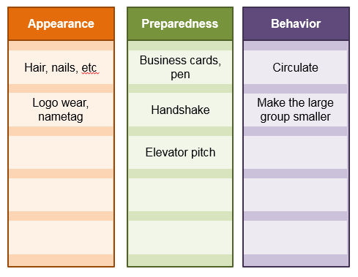

**Sending the RIGHT Message with Non-Verbal Communication**

|  |  |
| --- | --- |
| **Hands on hips** |  |
| **Rubbing eyes** |  |
| **“Crinkling” noise** |  |
| **Rubbing chin** |  |
| **Playing with necklace** |  |
| **“Steepling” hands** |  |
| **Interlocking hands** |  |
| **Hands behind head** |  |
| **Tilted head** |  |
| **Tapping fingers** |  |
| **Hands behind back** |  |
| **Hands folded in front** |  |
| **Brisk, erect walk** |  |
| **Locked ankles** |  |
| **Turning eyes away** |  |
| **Covering mouth while speaking** |  |

**Notes**

**Knowledge Check**

**Strike through any false statements.**

1. A successful networker gathers 10-20 business cards in a meeting.
2. Networking is selling or setting up appointments.
3. A successful networker has a prepared elevator pitch.
4. A successful networker is extroverted.
5. Networking is the exchange of advice, leads, contacts, and information

with others in your business community.

**Give one example from each networking group**.

1. Sphere of Influence 1. _______________________
2. Service Club 2. _______________________
3. Professional Trade Association 3. _______________________
4. Leads 4. _______________________
5. Social Media 5. _______________________

**The three confidence-building networking habits are**

_______________, ______________, & ________________

**Match the term to its possible interpretation.**

1. Tilted head A. Interest
2. Covering mouth while speaking B. Authoritative
3. “Steepled” hands C. Deceit
4. Rubbing eyes D. Disbelief

**Action Plan**

I will continue using these networking habits:

I will start a new networking group or activity in the next 21 days:

I will hold myself accountable by: